**Hypothesis Assignment Day 10**

**Step 1- Launching**

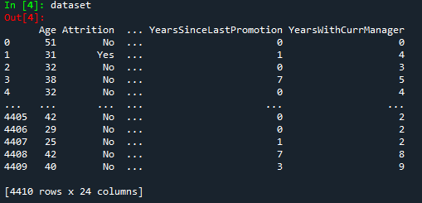

**Step 2- Data Treatment**

Removed Null and Duplicate Values

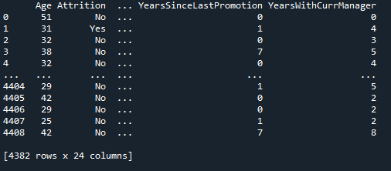

Created two dataframes-

* dataset1= attrition Yes
* dataset2= attrition No

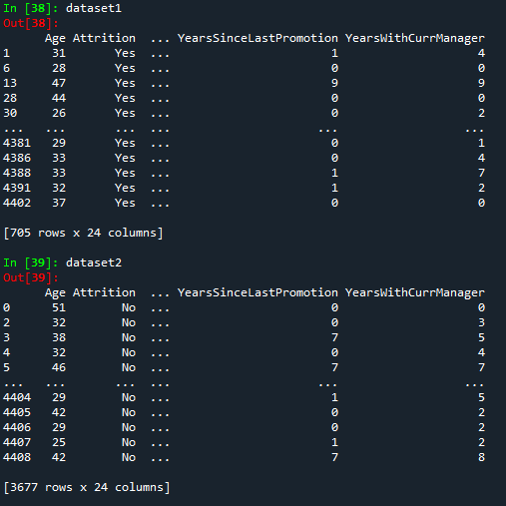

Data of Employees who left the Company-

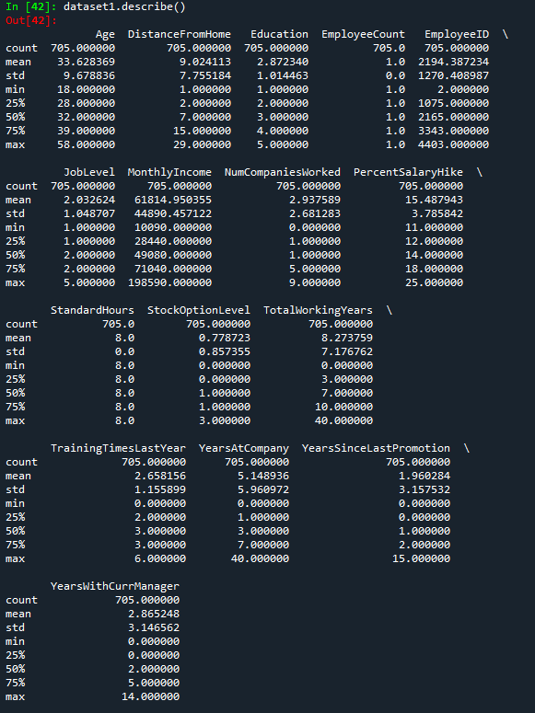

Data of Employees who did not leave the Company-

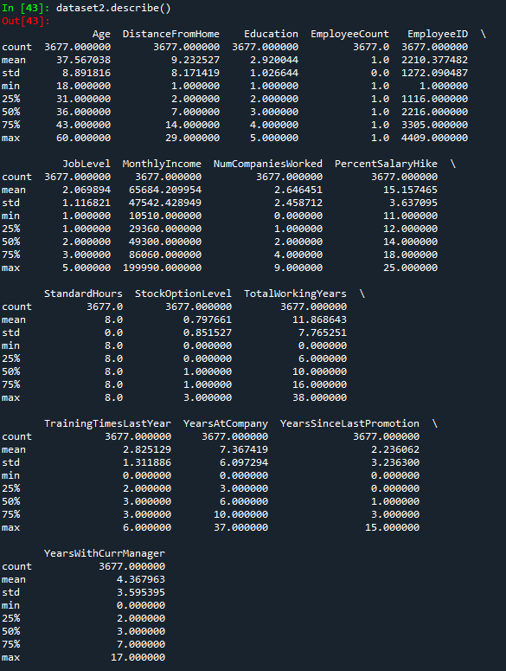

**Hypothesis on the above study-**

1. Employees with average age 33 has more chance of attrition.
2. Education has no effect on attrition.
3. Distance from home also has no effect on attrition.
4. Monthly Income also has no effect on attrition.
5. Number of Companies worked also has no effect on attrition.
6. Employees with Total Working Years < 10 have more chance of attrition.
7. Employees with ﻿Years at Company < 7 have more chance of attrition.
8. Employees with ﻿Years with Current Manager < 3 have more chance of attrition.
9. Training Times Last Year also has no effect with attrition.
10. Percent Salary Hike also has no effect on attrition.